Service provider part
The Idea from design service provider is support many customers with easy way and easy trouble shooting .
So that we use
( 1 ) MPLS to provide the following
- Assigns labels to each data packet, controlling the path the packet follows. MPLS greatly improves the speed of traffic, so users don't experience downtime when connected to the network.

- Virtual routing and forwarding provides a path to configuring multiple routing instances on either a router or Layer 3 switch. The purpose is to keep customer traffic and routing separate but through the same hardware.

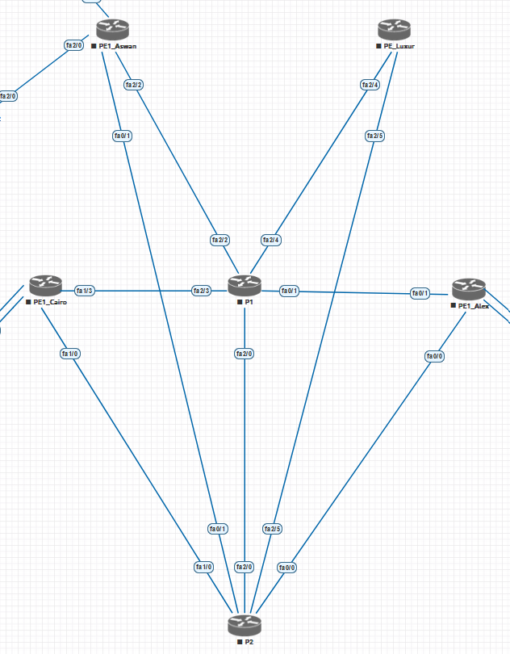

( 2 ) BGP to provide the following
- The PEs in the provider network using MPLS BGP use the Multiprotocol-Border Gateway Protocol (MP-BGP) to dynamically communicate with each other.

- To carry MPLS labels between routers .

( 3 ) OSPF as dynamic routing protocol

First ( MPLS usage )
In service provider network we use new address family,
it called ( VPNv4 )
VPNv4 consists of two addresses
- Route distinguisher to differentiate customer networks . ( RD _ 96 bit )
- Route target to vrfs ( RT _ 64 bit )

Second ( MP_BGP usage )
- In the design we used Route reflector routers ( P1 and P2 ) to support redundancy, availability and reduce number of BGP sessions between routers .
- MP_BGP carries RD and RT attributes .

Third ( OSPF )
To exchange network between routers

( Basic configuration to VRF ) Cairo branch
ip vrf CIB
rd 1:1
route-target 1:1

int loo 0
ip add 50.50.50.50 255.255.255.255
ip ospf 1 area 0

int loo 1
ip vrf forwarding CIB
ip add 40.40.40.40 255.255.255.255

int f0/1
ip vrf forwarding CIB
ip add 2.0.0.2 255.255.255.252
no sh

int f1/1
no swit
ip vrf forwarding CIB
ip add 1.0.0.2 255.255.255.252
no sh

( Basic configuration to mp_bgp )
router bgp 200
neighbor 100.100.100.100 remote-as 200
neighbor 100.100.100.100 update-source Loopback0
neighbor 200.200.200.200 remote-as 200
neighbor 200.200.200.200 update-source Loopback0

address-family vpnv4 unicast
neighbor 100.100.100.100 activate
neighbor 100.100.100.100 send-community extended
neighbor 200.200.200.200 activate
neighbor 200.200.200.200 send-community extended

address-family ipv4 vrf CIB
neighbor 10.10.10.10 remote-as 100
neighbor 10.10.10.10 activate
neighbor 10.10.10.10 update-source Loopback1
neighbor 10.10.10.10 ebgp-multihop

note
( the same configuration on Alex and Aswan with difference in IPS )

